Algebra 1: Unit 11, Lesson 2

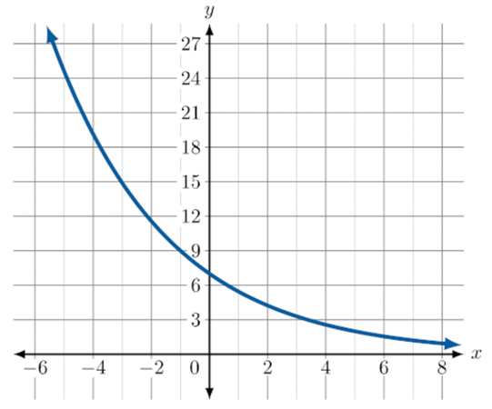
- A table of values and graph are shown.
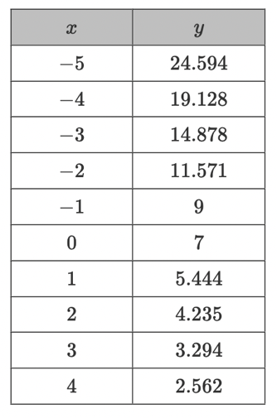
As the $x$-value _______________, the $y$-value approaches zero.
increases

- The graph of $y=4{\left(\frac{2}{3}\right)}^{x }$is shown on the coordinate plane.
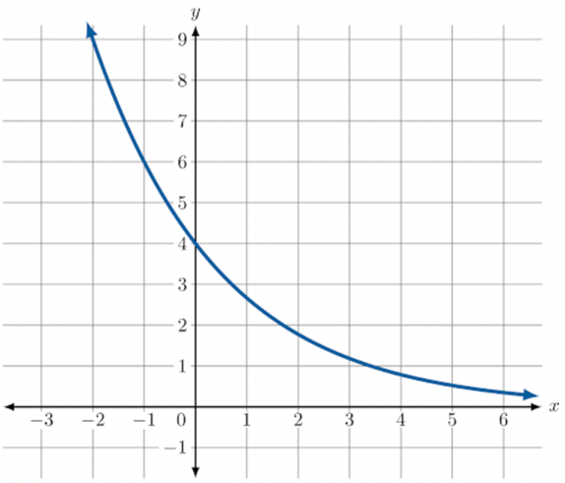
The equation $y=4{\left(\frac{2}{3}\right)}^{x }$demonstrated exponential decay because the value of $b$ is ___________ than $1$.
less

- What is the range of the equation $y=-{\left(\frac{1}{5}\right)}^{x }?$
$$y<0$$

